Assessment :

Pseudo code 10 Marks
Q1 : Write a Pseudo code for verify if number entered is prime number.
BEGIN
Input a number n,i ,a,Counter// n for number , i for iteration,a for loop, Counter for count of divisor
Store number in n
for i=1 to n by 1 do

store (n mod i ) in a
if a=0
increment counter by +1
End If
End For
if counter is 2
then print “ Number n is prime.”
Else print “ Number n is not prime.”
END

Q2: Write a Pseudo code for transferring amount from one account to another. [Should validate whether both accounts exists]
Begin
Input Account_number_to_be_transferred_from ,
Account_from_balance,
Name_of_first_account_holder ,
Account_number_to_be_transferred_to,
Account_to_balance,
Name_of_Second_account_holder
Amount to be transferred
Store Account_number_to_be_transferred_from in A1
Account_from_balance in Balance1
Name_of_first_account_holder in Name_1
Account_number_to_be_transferred_to in A2
Account_to_balance in Balance2
Name_of_second_account_holder in Name_2
Amount to be transferred in Amt

if A1 exists under Name1 and A2 exist under Name2
Then
Print “ Both the account Exist we can proceed with the further transaction”
if (Amt>Balance1)
Then
Print “You don't have enough balance to transfer.”
Else
Print “Transfering Amt from A1 to A2
Balance1 = Balance1- Amt
Balance2 = Balance2+ Amt

Print for Name1 “ Amount Amt debited from your account, available balance is Balance1”
Print for Name2 “ Amount Amt credited to your account, available balance is Balance2”

Else
Print “Account does not exit please enter a valid details”
END

RDBMS: 30 Marks
Q1. Write SQL Query to create following tables [DO NOT CREATE PRIMARY / FOREIGN KEYS ]
Customer: CustomerId, Fullname, address, city, pan number
Account: accountNo, accType, balance, customerId

Create table Customer (
CustomerId Varchar (20) not null Unique,
Fulllname varchar (20),
address varchar (20),
City varchar(20),
pan number varchar(20) Unique,
);

Create table Account (
accountNo Varchar (20),
accType Varchar (20),
balance Varchar (20),
customerId Varchar (20)
);

Q2. Write SQL to insert following records in Customer & Account tables:
C1002 | Rajiv Bhatia | Xyz Path, Chandni chowk | Delhi | AXNSS 1234 A
C1003 | Alia Bhatt | Khar | Mumbai | SZAXS 5656 B
C1004 | Vijay Deol | Bandra | Mumbai | APOI 5675 A
C1005 | Ajay Deol | Bandra | Mumbai | AUIO 7676 K

Insert into Customer
(CustomerId, Fullname, address, city, pan number)
Values
('C1002', 'Rajiv Bhatia','Xyz Path, Chandni chowk','Delhi','AXNSS 1234 A'),
('C1003', 'Alia Bhatt','Khar','Mumbai','SZAXS 5656 B' ),
('C1004','Vijay Deol', 'Bandra' , 'Mumbai', 'APOI 5675 A'),
('C1005', 'Ajay Deol','Bandra', 'Mumbai', 'AUIO 7676 K' );

SB122666 | Savings | 67000 | C1002
CB565556 | Current | 786928.98 | C1002
SB876565 | Savings | 547899.90 | C1004
SB565722 | Savings | 67600 | C1003
SB757676 | Savings | 66197.88 | C1003
SB166778 | Current | 16000 | C1008

Insert into Account
(accountNo, accType, balance, customerId)
Values
('SB122666','Savings','67000','C1002'),
('CB565556', 'Current', '786928.98','C1002' ),
('SB876565','Savings', '547899.90', 'C1004' ),
('SB565722', 'Savings', '67600','C1003' ),
('SB757676','Savings', '66197.88', 'C1003'),
('SB166778','Current','16000','C1008');

Q3. Write a Left Join to get all customers and accounts. Join should display all customers [Even those who DO NOT have any account].

Customer: CustomerId, Fullname, address, city, pan number
Account: accountNo, accType, balance, customerId
Select c.CustomerId, c.Fullname, c.address, c.city, c.pan number,a. accountNo, a.accType, a.balance
From Customer.c Left Join Account.a
Where c.CustomerId=a.CustomerId;

UML 10 Marks
Q1. For RDBMS Question #1, Create Class Diagram for Both tables.
Customer: CustomerId, Fullname, address, city, pan number
Account: accountNo, accType, balance, customerId

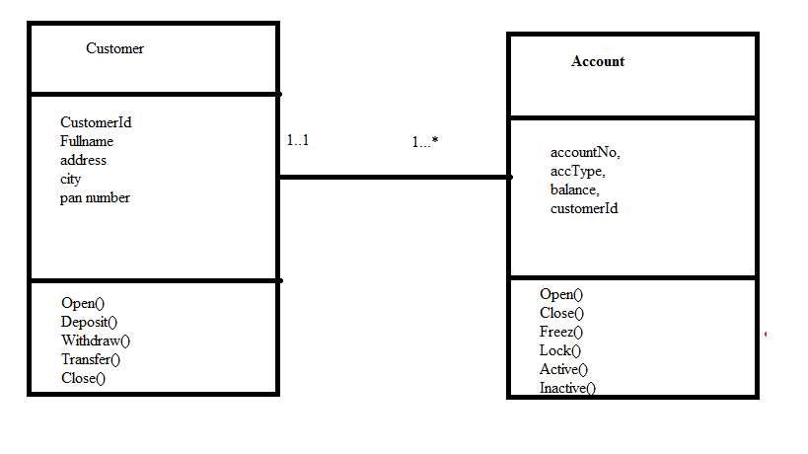

Q2. Create an Activity Diagram to explain fund transfer.
HINT: Fund transfer is possible from Any account type to any other account type.
Must validate existence of both account
Must validate account balance before transfer
Must update balance after transaction completes.

